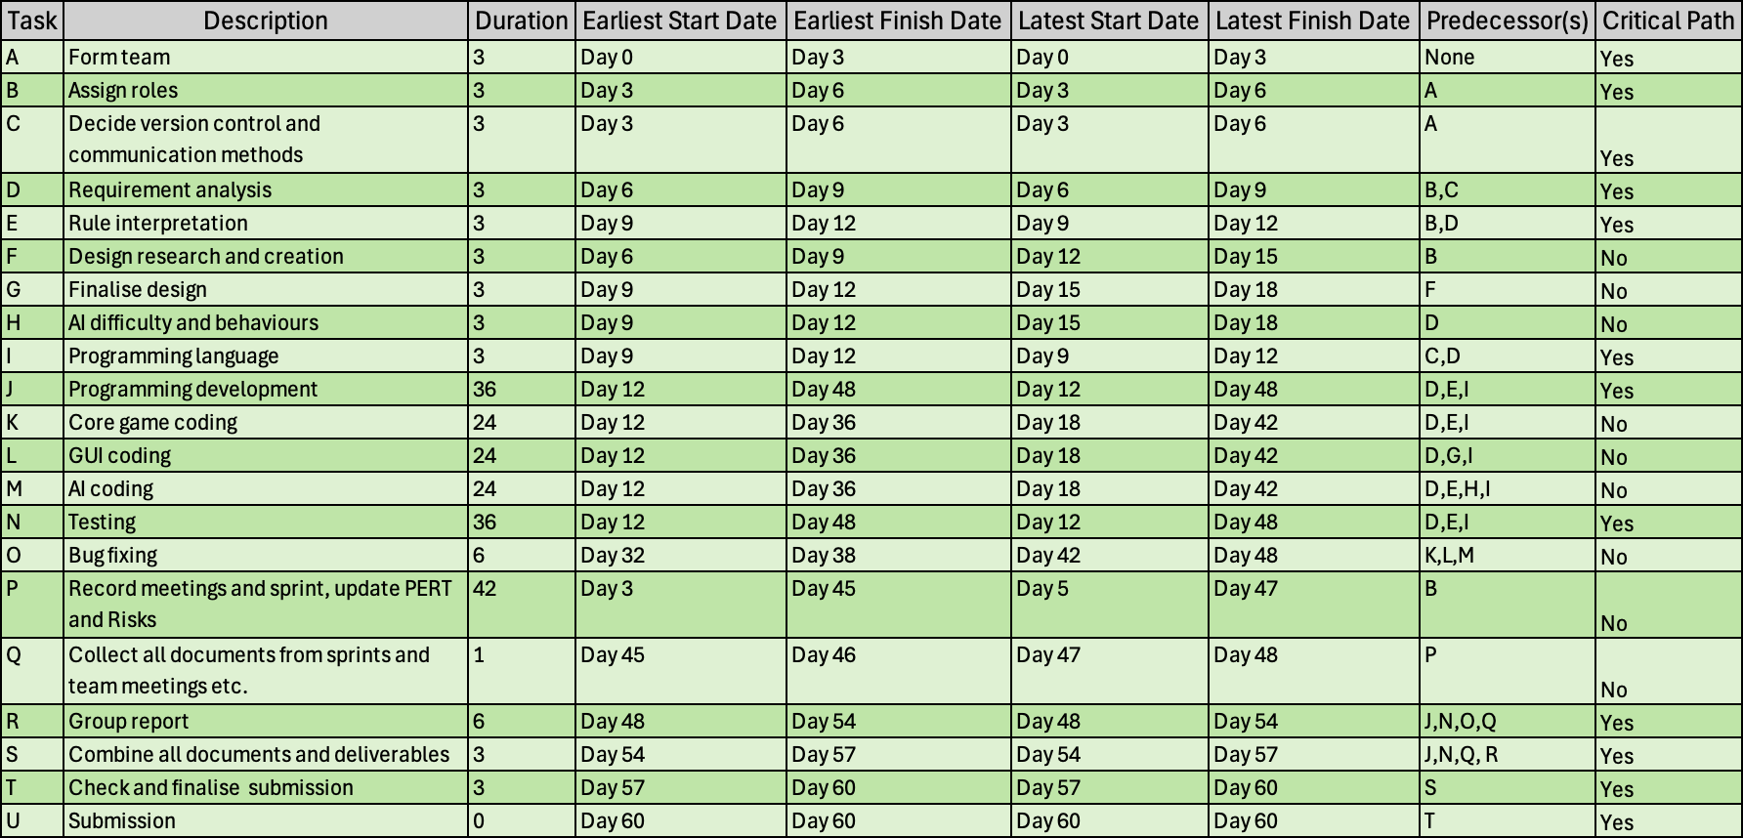
PERT Document
Duration is in days, working 6 days a week. Day 0 is the start of the project, so the beginning of week 1, and day 60 is the end of week 10. We plan to have most documents and deliverables prepared and ready by the end of week 9, allowing week 10 to finalise and double-check all work – aiming for submission by the end of week 10. This allows us a week of slack if anything goes wrong or is delayed.
This is also an updated PERT document, as the previous PERT document was showing what tasks need to be completed in a vague order, rather than in this format.
Progress is well under way.
Thursday 20th February 2024.

